PROJECT DEVELOPMENT DOCUMENT

AI-Based Financial Transaction Analysis System Using OCR and BERT

Name | Abhradip Seth
UID / Roll | TNUR20241053024
Department | Computer Science & Engineering (AI & ML)
Semester | 5th
University | The Neotia University
Internship Company | Kognitive
Internship Duration | 15th June 2026 to 9th July 2026
Submitted To | Bikash Bej

Table of Contents
Table of Contents 1
1. Abstract 1
2. Introduction 1
2.1 Objectives 1
2.2 Advantages 1
3. Methodology 1
4. Technical Components 1
4.1 Project Architecture 1
4.2 Data Schema 1
4.3 Model Training 1
4.4 Testing 1
4.5 Prediction Process 1
5. Visualization 1
6. System Architecture 1
7. Final Outcome (Results & Discussion) 1
7.1 Results 1
7.2 Future Scope 1

1. Abstract
The AI-Based Financial Transaction Analysis System is a web-based application that automates the extraction, classification, and visualization of financial transactions from bank statement PDFs. The system uses Optical Character Recognition (OCR) to extract text from scanned documents and applies BERT (Bidirectional Encoder Representations from Transformers) for intelligent transaction classification. The extracted transactions are displayed through interactive dashboards, including pie charts and bar charts. Developed using Python and Streamlit, the system provides an efficient, accurate, and user-friendly solution for financial analysis while significantly reducing manual effort.

2. Introduction
Financial institutions and individuals handle numerous bank statements every month. Manual analysis of these statements is time-consuming and error-prone. The objective of this project is to automate financial transaction analysis using Artificial Intelligence and Machine Learning techniques.

2.1 Objectives
- Extract transaction details from PDF bank statements.
- Automatically classify transactions using BERT.
- Display categorized transactions.
- Generate graphical reports.
- Provide a secure login interface.
- Improve speed and accuracy compared to manual analysis.

2.2 Advantages
- Saves time
- Reduces human error
- Easy to use
- Automatic categorization
- Better financial insights

3. Methodology
The project follows a structured seven-step workflow, illustrated below:

Step 1: User Login
Users log into the system using a secure authentication page.
↓
Step 2: Upload Bank Statement or payslip
The user uploads a PDF bank statement.
↓
Step 3: OCR / Text Extraction
The system extracts text from the uploaded document.
↓
Step 4: Data Preprocessing
Remove unwanted characters • Clean extracted text • Split into transactions
↓
Step 5: Transaction Classification
Cleaned transactions are passed into the trained BERT model,
which predicts categories such as Food, Shopping, Salary,
Travel, Bills, Entertainment, and Others.
↓
Step 6: Data Visualization
Generate Pie Chart, Bar Chart, and Transaction Table.
↓
Step 7: Financial Report
Display categorized transactions and analysis.

4. Technical Components
Component | Technology Used
Programming Language | Python 3.12.10
Frontend | HTML
Backend | Python
Machine Learning Model | BERT
OCR Library | Tesseract OCR
Data Processing Libraries | Pandas, NumPy, Regular Expressions (re)
Visualization Library | Matplotlib
PDF Processing | pdfplumber, PyMuPDF (fitz)
Other Libraries | transformers, torch, scikit-learn

4.1 Project Architecture
User
↓
Login Page
↓
Upload Bank Statement
↓
OCR Engine
↓
Text Extraction
↓
Data Cleaning
↓
BERT Model
↓
Transaction Classification
↓
Database / Memory
↓
Dashboard
↓
Pie Chart + Bar Chart + Transaction Table

4.2 Data Schema
Input: Bank Statement PDF
Extracted Fields:
- Date
- Description
- Amount
- Debit
- Credit
- Balance
Output Fields:
- Transaction
- Category
- Amount
- Prediction Confidence

4.3 Model Training
Dataset: Bank transaction dataset containing Transaction Description and Category Label
Preprocessing:
- Lowercase conversion
- Remove special characters
- Tokenization
- Padding
- Attention masks

Training Parameter | Value
Model | BERT-base-uncased
Optimizer | AdamW
Loss Function | CrossEntropyLoss
Epochs | 3 – 5
Batch Size | 16
Learning Rate | 2e-5

4.4 Testing
The trained model predicts transaction categories for unseen bank statements. Sample predictions are shown below:
Transaction | Predicted Category
Amazon Purchase | Shopping
Swiggy | Food
Salary Credit | Salary
Uber Ride | Travel

4.5 Prediction Process
Input Transaction
↓
Tokenizer
↓
BERT Encoder
↓
Classification Layer
↓
Predicted Category

5. Visualization
The following screenshots illustrate the application's user interface and outputs. (Insert actual screenshots of the application in place of the placeholders below.)
Screenshot 1: SignIn Page
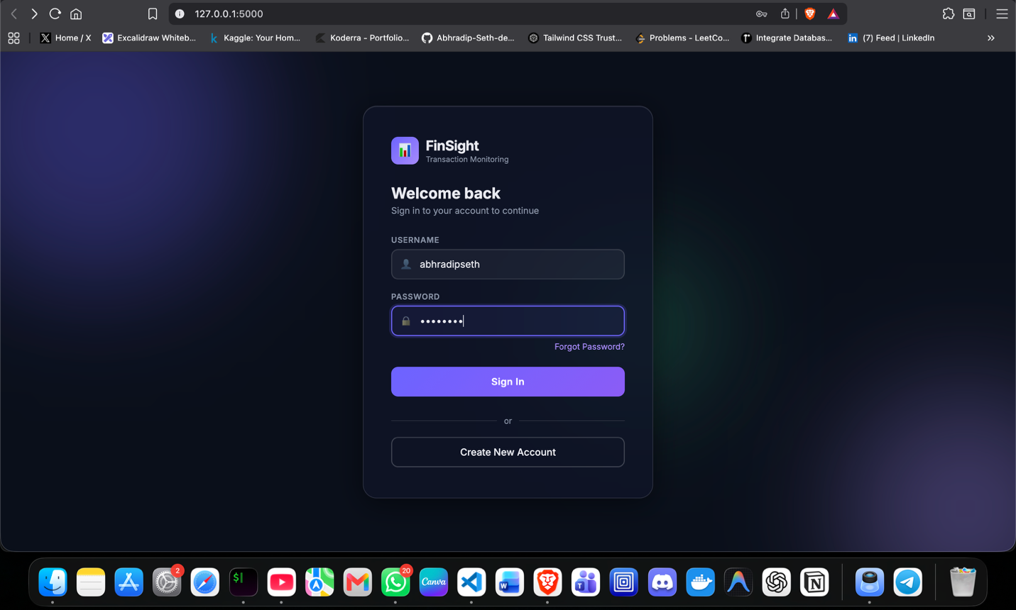
Description:
- Username field
- Password field
- SignIn button
Screenshot 2: Upload Page
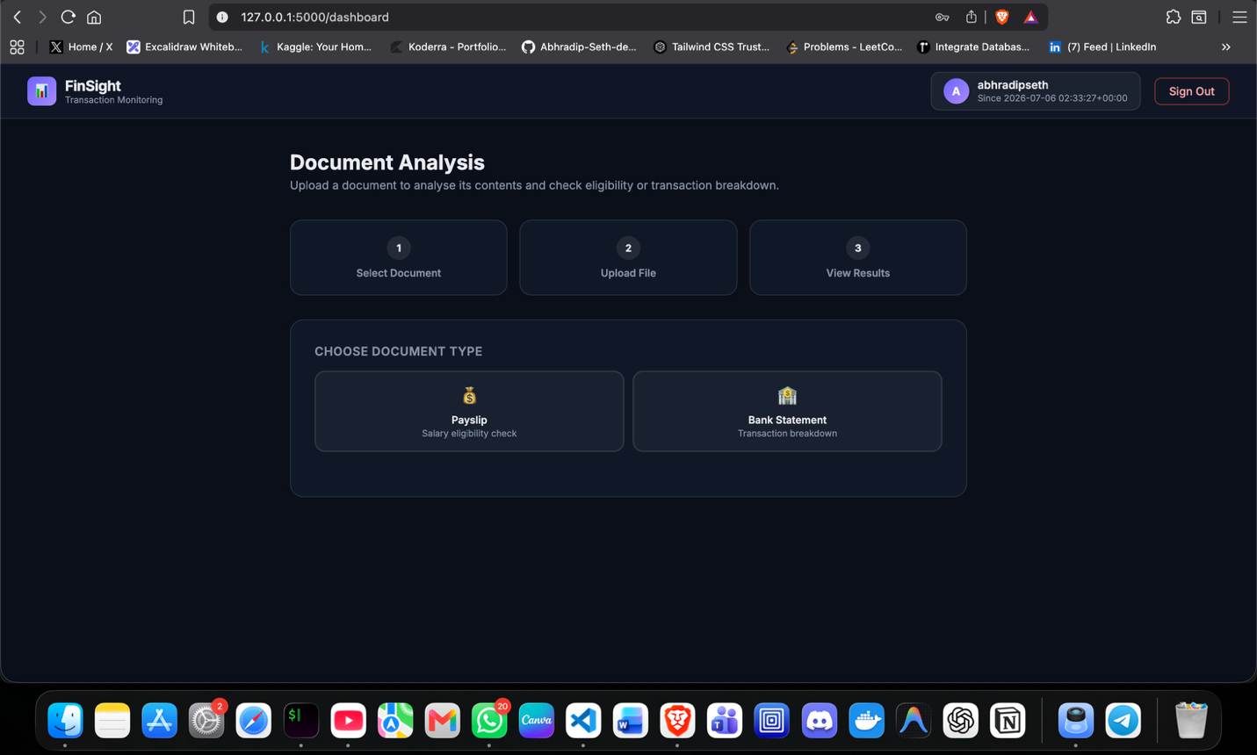
Description:
- Payslip and Bank statement upload page
Screenshot 3: Upload button
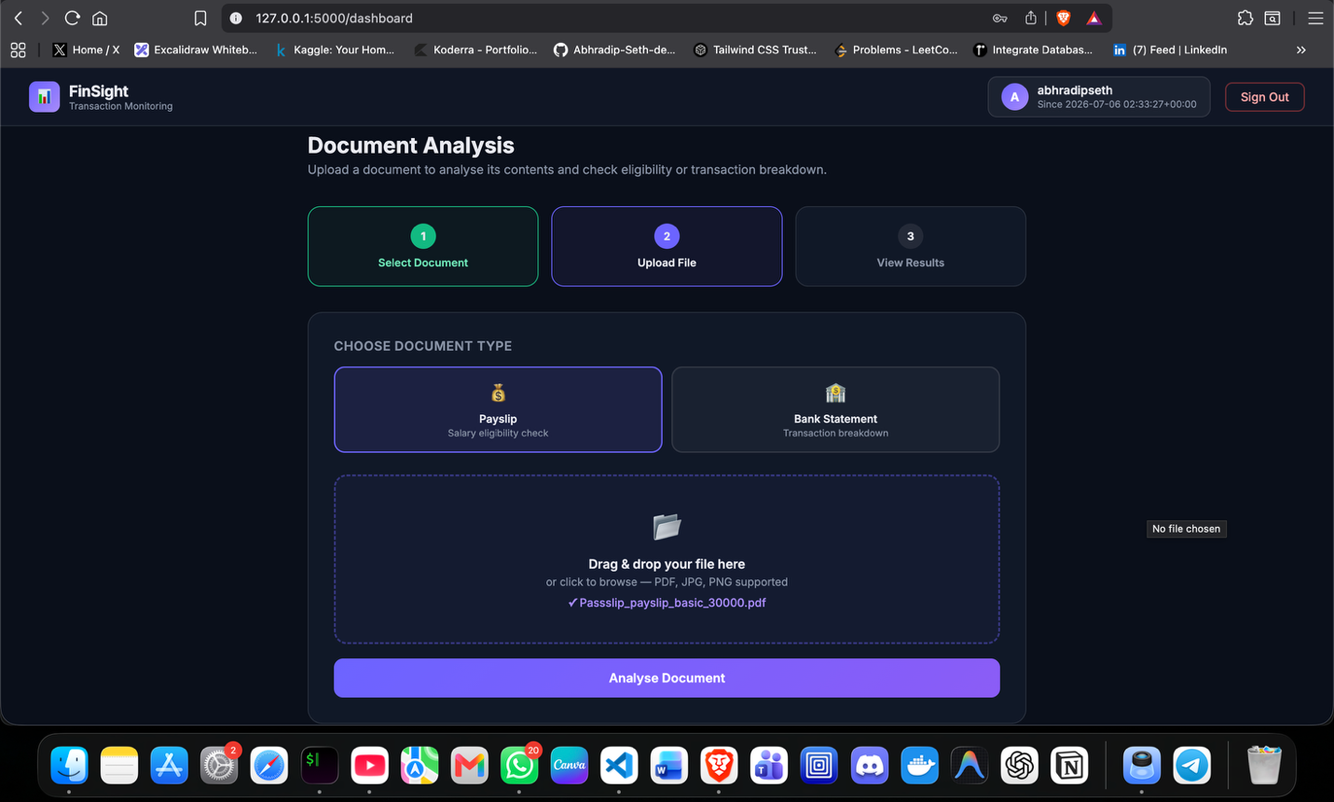
Description:
- After upload of any of the document (payslip/bank statement) there is an Analyse Document button to start the analysis of the document
Screenshot 4: Pie Chart
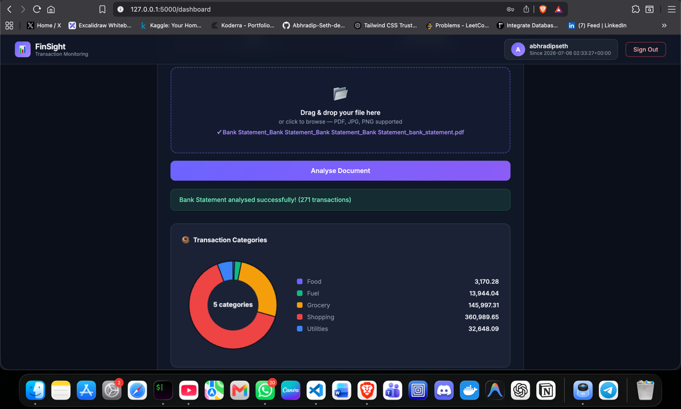
Description:
- Shows percentage distribution of transaction categories.
Screenshot 5: Bar Chart
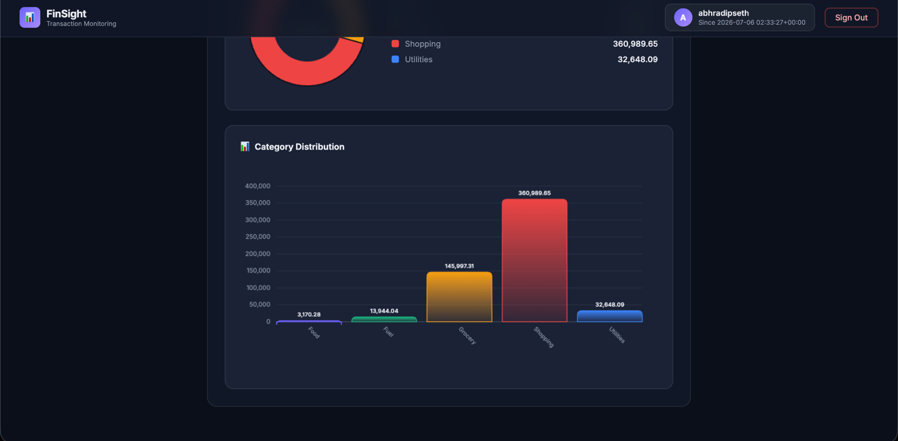
Description:
- Displays total transaction amount for each category.

6. System Architecture
User
↓
Login Module
↓
Upload Bank Statement
↓
OCR Text Extraction
↓
Data Preprocessing
↓
BERT Classification
↓
Transaction Table + Visualization (Pie Chart, Bar Chart)
↓
Financial Report

7. Final Outcome (Results & Discussion)
The developed system successfully automates the extraction and classification of financial transactions from bank statement PDFs. OCR accurately extracts transaction details, while the BERT model classifies transactions into meaningful categories with high accuracy. The interactive dashboard presents results using tables, pie charts, and bar charts, making financial analysis simple and intuitive.

7.1 Results
- Automated transaction extraction
- Intelligent transaction categorization
- Interactive visualizations
- Reduced manual effort
- Faster processing
- Improved accuracy
- User-friendly Streamlit interface

7.2 Future Scope
- Multi-bank statement support
- Real-time transaction analysis
- Mobile application
- Expense prediction using AI
- Budget recommendation system
- Integration with cloud databases
- Advanced fraud detection using deep learning

